|  |  |
| --- | --- |
| TEAM ID | NM2023TMID14700 |
| PROJECT NAME | Drowsiness detection and alerting system |

INTRODUCTION :-

1. Drowsiness is a condition which diminishes the awareness caused by the absence of rest or weariness.

Because of weariness, driver lose their control which may divert them from the street and prompts serious mishaps. Basically these mishaps may because of the driver tired condition. Driving continuosly for quite a while prompts tiredness and make them to lost their awareness. Due to substantial increment in the number of mischances day by day which makes a major issues.

Therefore, a model is required to keep the driver in the engaged state. The goal of

our model is to make a driver weariness location which demonstrates driver's lethargic condition through their face. The thought is to build up the model that will persistently recognize the driver's exhaustion progressively. One of the identification procedure is Percentage of squinting of eyes. Here we utilize a system totally in view of the development of eyes. The perception of eye development is essentially in view of the driver's condition. On the off chance that the individual is expending liquor it can be effortlessly identified by alcoholic sensors and if any temperature misused it can be recognized by temperature sensors.

The spillage of gas can likewise be

distinguished by the gas sensors. In request to identify the driver's laziness different methods has been implemented. But no strategy has been actualized to stop the auto naturally if the weakness or sluggish mode is identified. The most widely recognized strategy to distinguish the driver's state is of utilizing face detection. primarily focuses on the edges of the face through which the weakness condition is obtained. The larger part of the street mishaps can be counteracted by these techniques. In request to show the driver about his condition, an Alarm is produced. It can be either through vibrating caution or beep sound. The sign for the behind vehicle might be shown in the LED's. The principle goal of the street mischances basically relies upon the driver's distraction. It might be as tiredness, stress, consumption of alcohol,mobile utilization etc. In request to stay away from those diversion, a predefined demonstrate is designed.

Such a model can be a preventive procedure to decrease the street mishaps.

The rate of street mischances has been expanded in the current years in all nations as indicated by the current survey.

Small obliviousness of a driver can prompt awesome misfortune. It might be either physiological or prudent issues.

***Abstract***­ :-

A majority of road related accidents are due to driver’s fatigue, distraction and drowsiness.

Recentlyaccidents are increased at large amount. Various new creative technologies are introduced to avoid and reduce these accidents.

In these accidents, driver can meet severe injuries and even death. These may lead to significant economicloss.

This system can reduce the road related accidents due to driver’s fatigue. Our main objective is to develop amodel which can detect the driver’s drowsiness and indicate the driver’s condition by alarm.

Here we provide aprevention technique using eye blink and where we can stop the vehicle to avoid collision of vehicle.

1. **COMPONENTS AND ITS DESCRIPTION**

*Microcontroller*

The AT89S52 is a low-control , overwhelming 8-bit Microcontroller with 4K bytes of Flash programmable

and erasable read just memory . The device is made with high-thickness non erasable memory development and is

great with its efficiency. The on-chip Flash enables the program memory to be recorrected in-framework or by a

standard nonvolatile memory programming . By joining convenient 8-bit CPU with Flash on a solid chip, AT89S52is a capable microcomputer which gives an astoundingly

flexible and monetarily competent reaction for someinserted various control purposes.

Atmel code memory demonstrate is changed byte bybyte in either programming scheme. To program anynonblank byte in the on-chip Flash Memory, the wholememory must be deleted utilizing the clear mode.

The system uses a small infra-red night vision camera that points directly towards the driver's face and monitors the driver's eyes in order to detect fatigue. In such a case when fatigue is detected, a warning signal is issued to alert the driver.

Driver drowsiness detection systems can use cameras, eye tracking sensors and other hardware to monitor visual cues, where drowsiness can be detected through yawning frequency, eye-blinking frequency, eye-gaze movement, head movement and facial expressions.

EMPATHY MAP:-

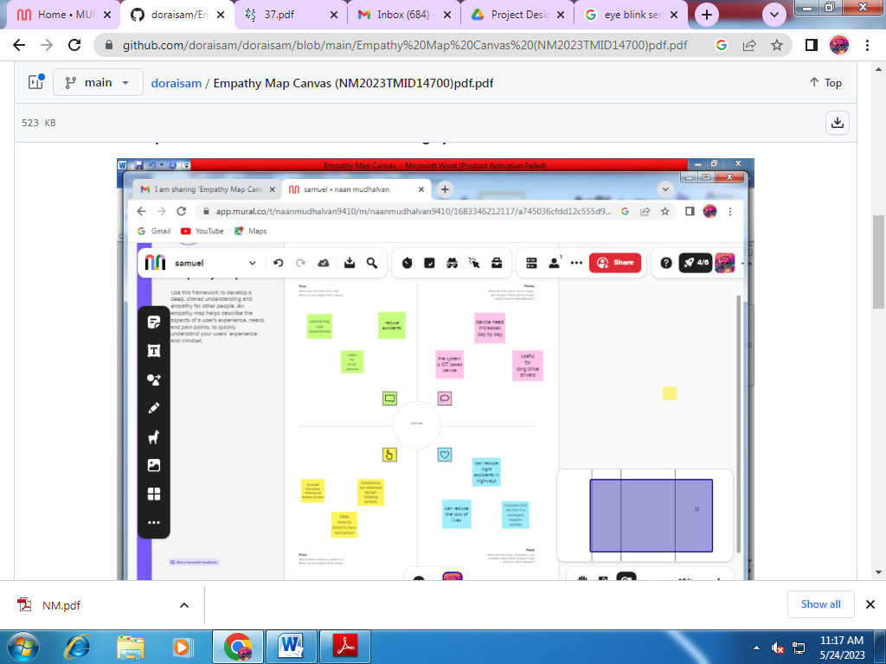

**BRAIN STORMING :-**

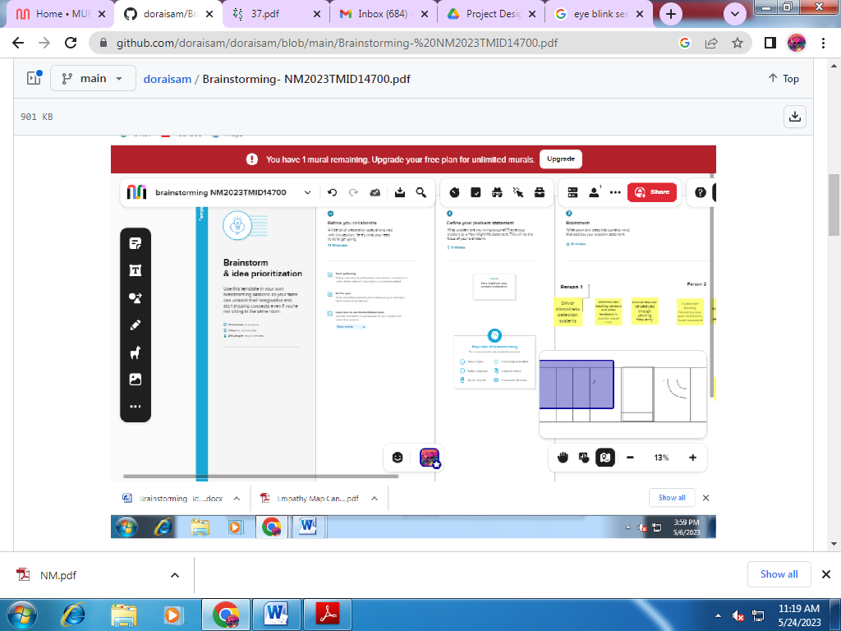

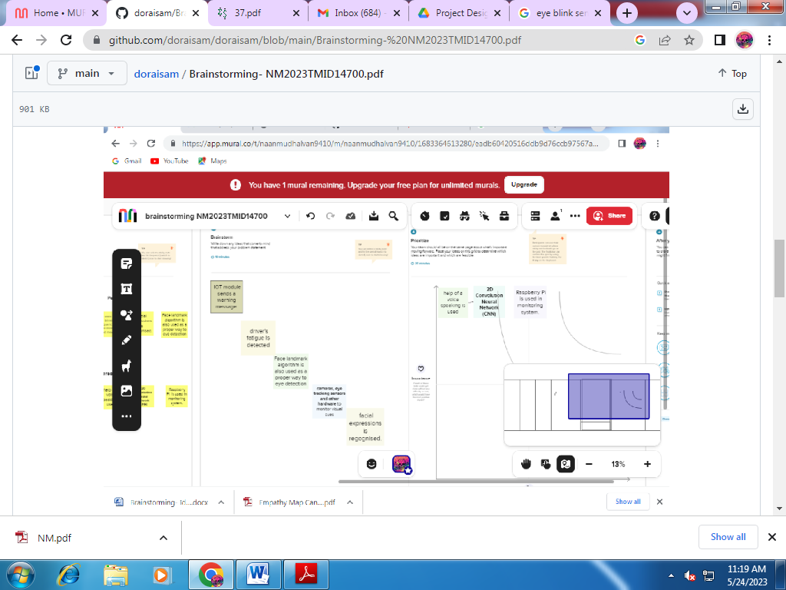

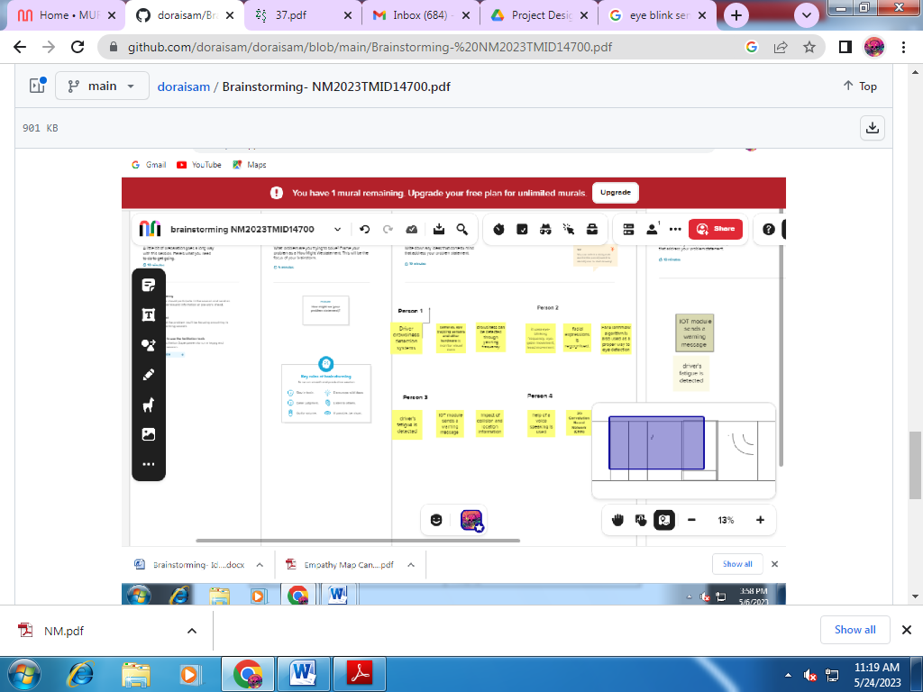

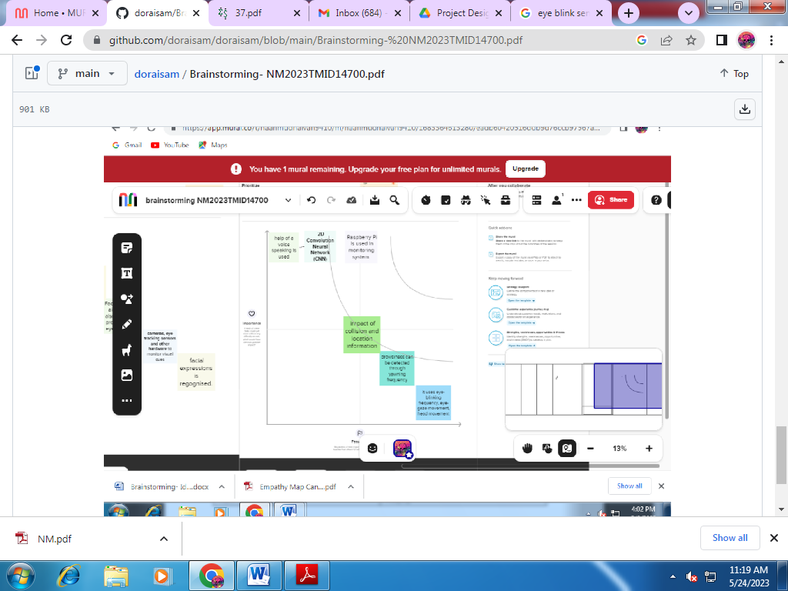

**PROBLEM STATEMENT**:-

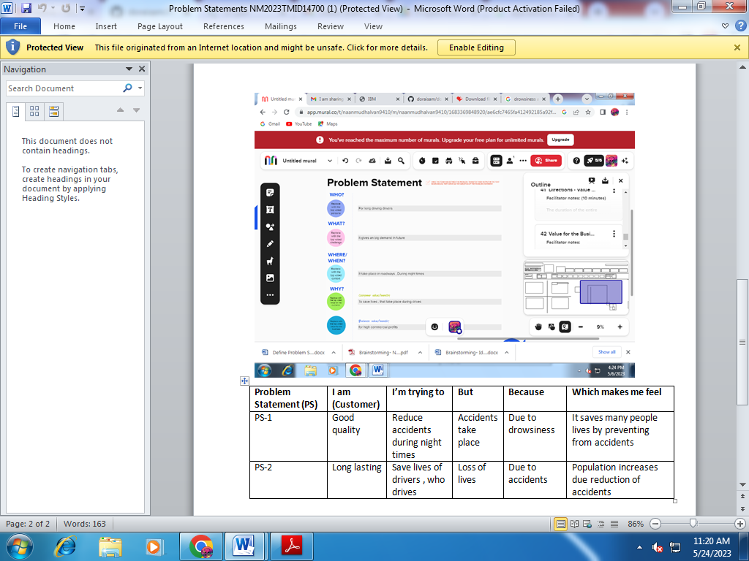

***TEMPERATURE SENSOR :-***

They are different types of sensors available now adays, running from soil sensor,

proximity sensor, stickinesssensors, ultrasonic sensors and different more( improvementsensors, touch screens). Endless are clear in general.

That gathers they give a voltage yield that shifts especially (andclearly) with the distinguished entirety. For instance in

LM35 temperature sensor, the yield voltage is 10mV for

each degree centigrade. That surmises if yield is 300mVthen the temperature is 30 degrees. In this instructional

exercise we will understand how to interface LM35temperature sensor with PIC18F4520 microcontroller andexhibit its yield on the Liquid Crystal Display module.

Switch on the voltage, the screen should display thereadings. Bring a Heated appending iron ends close to theLM35's pins, keep it 1 or 2mm away.

The screen shouldresuscitate with the increasing degree.

Before long at longlast touch the pins of LM35 with the tip of iron, the degree

will increase rapidly.



Figure. 1 Temperature Sensor

Keep it there until the point that degree move to 80,by then clear the rod. You would now have the ability to abandon your mouth on the sensor to chill it off.

***Alcoholic sensor :-***

They are used as a piece of gas spillage recognizing kinds of apparatus in family and industry, are sensible for perceiving of LPG, vaporous oil , town gas, keep up a key

separation from the uproar of alcohol and cooking vapor and tobacco smoke.

Its features are: High sensitive to LPG, vaporous

petroleum , town gas, Small sensitivity to alcohol, fog,rapid process, Stable and long life, Simple drive circuit.

Assurance estimation of MQ-5 is qualification to various sorts and diverse obsession gases. Thusly, When using this

parts, affectability alteration is amazingly basic.

We recommend that you change the discoverer for 1000ppm H2

or LPG obsession in air and use estimation of Load security ( RL) around 20 KΩ(10KΩ to 47KΩ).When unequivocally

assessing, the right alarm point for the gas pointer should besettled ensuing to considering the temperature and stickiness

affect.

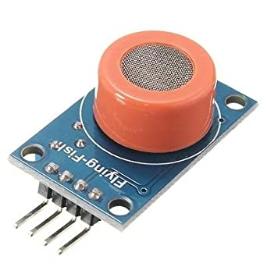

Figure .2 Alcoholic sensor

***LCD:-***

A liquid diamond appear (regularly truncated LCD)is a scanty, device made up of any number of fading orsingle color pixels displayed before a light resource .

It is routinely utilized as a part of battery-filled electronic contraptions since it uses little measures of electric power.

Every pixel of a LCD generally involves a layer of particles balanced among two direct terminals, and two channels, the

tomahawks of sharing of which are (in most of the cases)inverse to each other.



Figure.3 LCD Display

With LCD Display between the polarizing channels, light using the primary procedure will beobstructed by another polarizer. The surfaces of thecathodes that are overlapped with the liquid jewel material are managed keeping in mind the end goal to modify the

liquid diamond molecules in a particular head in. This method customarily includes a thin polymer layer that issingle direction rubbed using, for example, a material. The

heading of the liquid valuable stone game plan is thendescribed by the course of rubbing.

***Eye blink sensor:-***

Eye blink sensor is used to demonstrate the eyeblink count of the people. On the off chance that the eyeblink count is reduced it can be shown by this sensor. This sensor has two sections. They are IR transmitter and IRbeneficiary. These two segments are put parallel to eachother.

These sensor is set in the scenes. It is a comparative standard in all IR sensors.

The main objective is to pass IR

light into IR-LEDs, which is then reflected by any inquiry before the sensor. At that point you should essentially to get

the shared light.

For perceiving IR light, we will use an

amazingly remarkable strategy: we will use another IRLED,to recognize the IR light that was transmitted from another determined of accurately the same is an physical

property of LED, the way that a drove generate a power differentiate over it directs when it is fed to light just as it was a light cell, however with much smaller yield electrons.By the end, the power delivered by the LED's which is used to make the power, it can be recognized.

In the schematic,we will use an amplifier to decisively recognize little voltage changes.

***Alarm:-***

This novel bell circuit utilizes a transfer in

arrangement with a little sound transformer and speaker. At the point when the switch is squeezed, the hand-off will work by means of the transformer essential and shut transfer

contact.



Figure. 5 Alarm circuit

When the hand-off works the regularly shut contact will open, expelling power from the hand-off, the contacts close and the arrangement rehashes, all extremely quickly.

so quick that the beat of current causes variances in the transformer essential, and henceforth optional.

The speakers tone is along these lines

corresponding to hand-off working recurrence.

***Power Supply:-***

A power supply is a system which arranges distinctivevarieties of imperativeness to a get and arrange the weights.

This is typically associated with electrical imperativeness supplies, not often to their properties, and now and again to

others. Here we are using 5v to 12v. This square chart in our model comprise of eye flickersensor, alcoholic sensor, temperature sensor,microcontroller, LCD show, hand-off, light marker,

driver circuit, equip engine and LED. If the eye blink ofa man is diminished, at that point the caution will begiven to the driver through vibrating alarm or beepoff and

demonstrate to the vehicle coming at the posterior of the auto about the driver's condition. If the driver has devoured liquor it will be recognized by alcoholic sensor

and showed in LCD about the utilization. In our task the eye squint sensor is set close to the eye of the driver to detect the flicker check and this data is transmitted as

heartbeats and is given to the Microcontroller.

The Microcontroller utilizes the above data to contrast and the typical eye squint customized in the chip and if any strange circumstance emerges the vehicle is ceased with an alert sign, this activity is empowered by methods for the driver circuit associated with the vehicle engine.

This venture keeps the mischance because of liquorutilization.

The liquor devoured by the driver is estimated bysensor.

The yield from the sensor is given to the controller through the flag molding unit. On the off chance that any irregular condition happens the controller will caution and furthermore controls the speed of the vehicle.

By utilizing gear engine close to the motor can back off the auto and show for the vehicle behind keeping in mind the end goal to stay away from setback in rush hour gridlock areas.

In our framework we are utilizing LED, LCD and rigging motor.

LED is utilized to demonstrate the jumpers in rear of our vehicle.

LCD is utilized to show the states of the drivers climate he is in sleepy condition or not.

The drivers languor location is utilized to avoid mischances in street transportation.

It is one of the security innovation to counteract street mishaps that caused by the drivers tiredness or by expending liquor...

The buzzer is used to alert the driver whenever the driver feels drowsy. Whenever the sensor values are not in the range of threshold value, the motor stops.

In case of emergency, the GPS module determines the location and this information is sent through GSM to the particular person or in charge ward.

**Tools used in drowsiness detection :-**

The purpose of the drowsiness detection system is to aid in the prevention of accidents passenger and commercial vehicles.

The system will detect the early symptoms of drowsiness before the driver has fully lost all attentiveness and warn the driver that they are no longer capable of operating the vehicle safely.

Drowsiness is identified by using vision-based techniques like eyes detection, yawning, and nodding.

When it comes to yawning and nodding some people can sleep without yawning and nodding.

One more method is by using physiological sensors like biosensors.

The drowsiness detection system is capable of detecting drowsiness in quickly. The system which can differentiate normal eye blink and drowsiness can prevent the driver from entering the state of sleepiness while driving.

ADVANTAGES :-

The police can immediately trace the location where the accident has occurred and necessary action can be taken after receiving the emergency message.

The drowsiness detection system is capable of detecting drowsiness in quickly. The system which can differentiate normal eye blink and drowsiness can prevent the driver from entering the state of sleepiness while driving.

This system can prove to be a lifesaver in isolated areas where an accident has occurred and no one is around in order to report the accident.

**OBJECTIVES :-**

Drowsiness detection is a safety technology that can prevent accidents that are caused by drivers who fell asleep while driving. The objective of this intermediate Python project is to build a drowsiness detection system that will detect that a person's eyes are closed for a few seconds.

**FUTURE SCOPE :-**  
The system can be made more accurate using various other parameters such as State of the Car.

 Detecting Foreign Substances on Face etc.

An application can be developed where it can alert or prevent the user from sleeping.

**PROPOSED SYSTEM** :-



Figure. 6 Block diagram

**TRANSMITTOR MODULE** :-

In this venture if the eye won't squint 10-12

seconds continuously the eye flicker sensor will receive the infrared from the eye and transmit the infrared to the eye so by this sign it will give an alarm sound and it will back off.

The vehicle it will likewise show the vehicle will's identity returning at the of the vehicle.



Figure. 7 Transmittor module

**CONCLUSION:-**

This task speaks to a case of methodical way to deal with the appraisal of wearable sensors for physiological parameter estimation. In the event that it is settled in vehicles and utilized as an open source.

By this undertaking driver's laziness is checked persistently. In a bad position,

they will be frightened and display effortlessly. Of late according to IRB overview it had shown that 27 % street mishaps are expected the driver weakness, tiredness and laziness.

In order to keep away from street mishaps

outlining driver sluggishness location framework will be absolutely productive.

In this way it is presumed that eye checking framework is one of the quick technique for influencing driver to alarm if sluggishness or exhaustion is experienced while driving. It is a standout amongst the most proficient strategy that can help us to lessen occurrences of

lethal street mischances caused because of the driver weakness, languor and tiredness.

We built up a framework that restricted and track the eyes and head developments of

the driver keeping in mind the end goal to recognize laziness.

The framework utilizes a blend of layout based

coordinating so as to restrict the eyes.

**AMID FOLLOWING** :-

framework will have the capacity to choose if the eyes are open or shut and whether the driver is looking in front.

At the point when the will be shut for a really long time, a notice flag will be given as bell or caution pack message.

In future, this venture will be improved in flying machine framework for quick and precise execution.

**REFERENCES :-**

[1] Jayasenan J, Smitha P, Driver Drowsiness Detection

System, Journal of VLSI and Signal Processing,

Volume 4, Issue 1, Ver. I (Jan. 2014),

[2] Kanchan, Manohar Sontakke, Efficient Driver Fatigue

Detection and Alerting System, International Journal of Scientific and Research Publications, Volume 5, Issue

7, July 2015.

[3] K.Srijayathi, M.Vedachary, Implementation of the

Driver Drowsiness Detection System, International Journal of Science, Engineering and Technology

Research (IJSETR), Volume 2, Issue 9, September

2013

[4] Vandna Saini, Rekha Saini, Driver Drowsiness Detection System and Techniques: A Review,

International Journal of Computer Science and

Information Technologies, Vol. 5 (3) , 2014, 4245-

4249.

[5] Arun Sahayadhas , Kenneth Sundaraj and Murugappan

Murugappan, Detecting Driver Drowsiness Based on

Sensors: A Review,Sensors2012,12,16937-16953;

doi:10.3390/ s121216937, ISSN 1424-8220.

[6] Chisty, Jasmeen Gill, A Review: Driver Drowsiness

Detection System, International Journal of Computer.

**Github link :-**

**https://github.com/doraisam/doraisam**